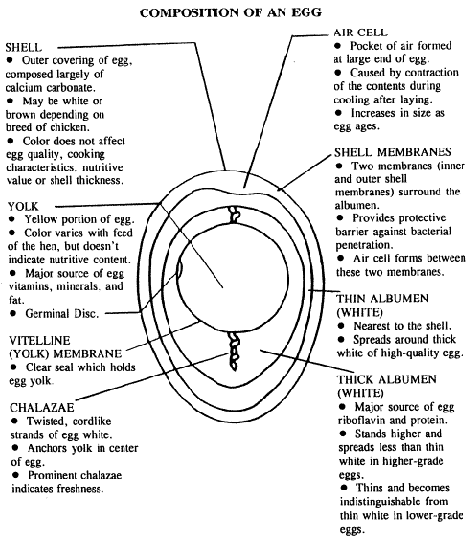
EGGS CAN ACT AS AN EMULSIFIER AND A LEAVENING AGENT
AN EMULSIFIER CAUSES OIL AND WATER TO MIX COMBINING THE TWO ELEMENTS.
WHEN EGG IS EXPOSED TO HEAT THEN THE PROTEINS OF EGG WHICH ARE IN THE LIQUID FORM ARE CONVERTED IN A GEL LIKE FORM AND THIS IS KNOWN AS EGG COAGULATION. THE WATER CONTENT OF EGG IS REDUCED BECAUSE THE FORMATION OF THE THREE DIMENSIONAL PROTEIN MOLECULES RESULT IN TRAPPING WATER CONTENT. WHEN EGG COAGULATION IS CARRIED OUT, IT STARTS SHOWING THE CHARACTERISTICS OF SOLID.

