**CHOCOLATE VARIETIES/FACTS**

More is not always better. When it comes to cacao percentage, finding the perfect percentage for you is more important than finding the highest cacao percentage available.

In the United States, a set of federal regulations, called the Standards of Identity, govern the composition and nomenclature of chocolate. Chocolate can be legally defined to fit into one of the different chocolate categories defined below. However, the Bittersweet and Semi-Sweet category encompasses a broad range of chocolate with different levels of cacao content. In order to provide consumers with more information about our chocolate,

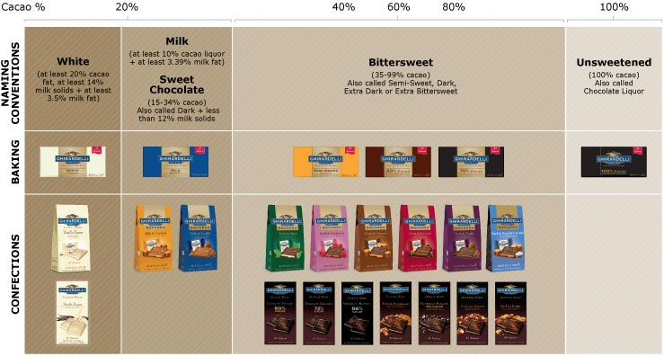

The following standards apply to all chocolates:

Unsweetened Chocolate (100% Cacao Content)

* Unsweetened Chocolate is also called chocolate liquor. It is made from finely ground roasted cocoa nibs.
* Can be natural or dutch (alkalized).

Bittersweet Chocolate (35-99% Cacao Content)

* Many types and brands of chocolate will fit into this category ranging from 35% cacao content to 99% cacao content. It must also contain at least 35% unsweetened chocolate and less than 12% milk solids.
* This category has many names including Bittersweet, Semi-Sweet, Dark, Extra Dark or Extra Bittersweet Chocolate.
* Generally, Bittersweet chocolate has an unsweetened chocolate content of 50% or more and Semi-sweet chocolate contains 35-45% unsweetened chocolate.

Sweet Chocolate (15-34% Cacao Content)

* Sweet Chocolate contains at least 15% unsweetened chocolate and less than 12% milk solids. Sweet Chocolate is more commonly called Dark Chocolate, although it has a lower cacao content than Bittersweet Chocolate.

Milk Chocolate

* Milk Chocolate contains at least 10% unsweetened chocolate, 12% milk solids, and 3.39% milk fat.

White Chocolate

* Previously there were no legal standards to define White Chocolate. The Standards of Identity recently created a legal definition to provide consumers with more information. White Chocolate must contain at least 20% cocoa butter, 14% milk solids, and 3.5% milk fat.

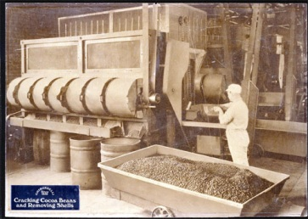 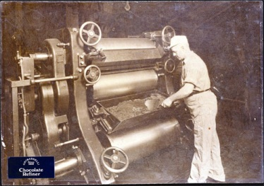

**THE HISTORY OF CHOCOLATE**

Chocolate's origins date back more than 4,000 years to the culture of the Mayas in Central and South America. It was introduced to Europe in the 1500s and reinvented by European chocolatiers as a sweet, creamy confection. In the 1800s, it was re-introduced to the New World and America.

|  |  |
| --- | --- |
| **Origin** | Amazon or Orinoco basin of South America approximately 4,000 years ago. |
| **600 A.D.** | The Mayas undertook a massive migration that led this highly civilized people from Central America deep into the northern regions of South America. In Yucatan, they established the earliest known cocoa plantations. There is no doubt, however, that the Mayas must have been familiar with cocoa several centuries earlier. |
| **1000** | From the very early days of cocoa, the peoples of Central America used beans as a form of payment. The use of cocoa beans as units of calculation must also have become established before A.D. 1000. One Zontli equalled 400 cocoa beans, while 8000 beans equalled one Xiquipilli. In Mexican picture scripts, a basket with 8,000 beans represents the figure 8,000. |
| **1200** | By subjugating the Chimimeken and the Mayas, the Aztecs strengthened their supremacy in Mexico. Records dating from this period include details of deliveries of cocoa that were imposed as tributes on conquered tribes. |
| **1502** | First European contact with cocoa beans (fourth voyage of Christopher Columbus). |
| **1528** | Hernando Cortez returns to Spain with cocoa beans, impressed by the fact that the Aztecs used them as currency. Hernando seeded plantations on Trinidad, Haiti, and the West African island of Bioko to grow "money" to trade with Aztecs for gold. Spain then had a virtual monopoly of the cocoa market for almost a century. |
| **Early 1700's** | The industrial revolution mechanizes chocolate making and brings the price within the public's reach. Chocolate houses start to spring up in England to compete with coffeehouses. (Chocolate at this point was consumed as a liquid beverage, not as a confection.) |
| **1765** | The first chocolate factory was established in Massachusetts Bay Colony. |
| **1828** | Conrad Van Houten, a Dutch chemist, learns to press cocoa butter out of chocolate liquor. This allows the production of cocoa powder. |
| **1848** | Conrad Van Houten adds cocoa butter and sugar to chocolate liquor and "eating chocolate" was created. |
| **1856** | Domingo Ghirardelli establishes his first chocolate factory in San Francisco, CA. |
| **1875** | Daniel Peter and Henri Nestle combine chocolate and milk powder and create the first milk chocolate bar. |
| **1879** | Rodolphe Lindt produces chocolate that melts on the tongue. He develops the "conching" process that gives chocolate a smoother texture. |