US Honors I
Research Assignment

Directions: Complete a four to five page paper on one the topic listed below. Your paper must follow all of the guidelines bellow.

Guidelines:

- 4 to 5 pages in length

- 12 point font size

- Times New Roman

- Double Spaced

- MLA Format

- Citations throughout text to support writing & key facts

- Works Cited Page

- Organized

- Grammatically correct

Topic:
Arab Spring
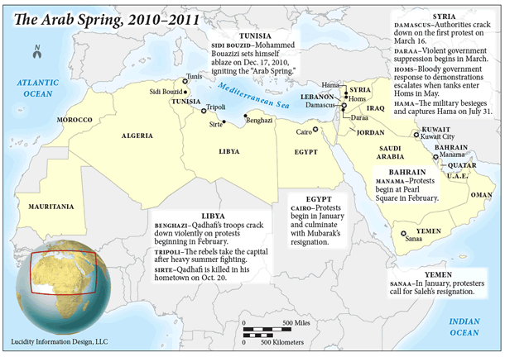
Directions:
Task 1
Go to the link http://pulitzercenter.org/education/lesson-plan/lesson-plan-writing-about-arab-spring . Read the sections entitled Introduction and Lesson Plan Description. After reading both sections respond to the questions below.
- What is the context of the Arab Spring?
- What were the causes of the Arab Spring?
Task 2
Read the descriptions below of possible paper topics and styles. Select the one that you find most interesting based on your understanding of the topic. Be prepared to share the reasons for your selection.

Informative Essay
Have your students select one country involved in the Arab spring movement and write an informative essay about it. The essay should include historical and political background information on the country, the major events of the uprising in that country, and a summary of what changes, if any, have taken place since the uprising. Students should use the timelines for country specific information, Pulitzer Center and other reporting pertaining to their country as resources.

Argumentative Essay
Have students write an argumentative essay on which factor was the most influential in causing the movement. Example factors: youth bulge, authoritarian governments, economic conditions, lack of rights. Students should use the background videos, timelines, Pulitzer and other reporting pertaining to the factor as sources.

Research Essay
Have students identify a theme or topic from the Arab spring that they would like to explore further. Encourage students to choose a theme or topic that is applicable to more than one country. Example themes/topics are: role of women, role of religious groups, role of media, role of youth, challenges for the future, etc. Students should use the background videos, timelines, and country/topic specific Pulitzer reporting as well as additional sources to complete this assignment.

Main website for research
http://pulitzercenter.org/education/lesson-plan/lesson-plan-writing-about-arab-spring
Arab Spring & Environmental Determinism Article
http://www.nytimes.com/2012/04/08/opinion/sunday/friedman-the-other-arab-spring.html?_r=0

