**My warmest thanks to the MES Administration, the Manasquan BOE, Cathy King, Kelly Gale, Donna White, Sam, Don, Harry, Mary, and EVERYONE who has helped bring this show to life.**

**“ The people you love will change you” My personal love and thanks to my incredibly family who is there to help every step of the way without a second thought.**

**ABOUT *MOANA***

*Moana* is a celebration of the rich stories of Oceania and is based on the beliefs and cultures of real people. In creating the original film, the producers at Disney Animation formed an Oceanic Trust. This group of anthropologists, cultural practitioners, historians, linguists, and choreographers from islands including Samoa, Tahiti, Mo’orea, and Fiji was integral in the creation of the film, providing feedback and notes on character design, song lyrics, and the depiction of culture onscreen. This respect and careful attention to detail was carried forward in the creation of *Moana JR.* for the stage. Each production of the show is supplied with a Director’s Guide, a Pronunciation Guide, and Choreography Video demonstrations, providing information, research, and best practices for respectfully celebrating Oceanic culture.

Disney’s *Moana JR.* is presented through special arrangement with

and all authorized materials are supplied by

Music Theatre International, New York, NY

(212) 541-4684 mtishows.com

**MES Drama Club’s**

production of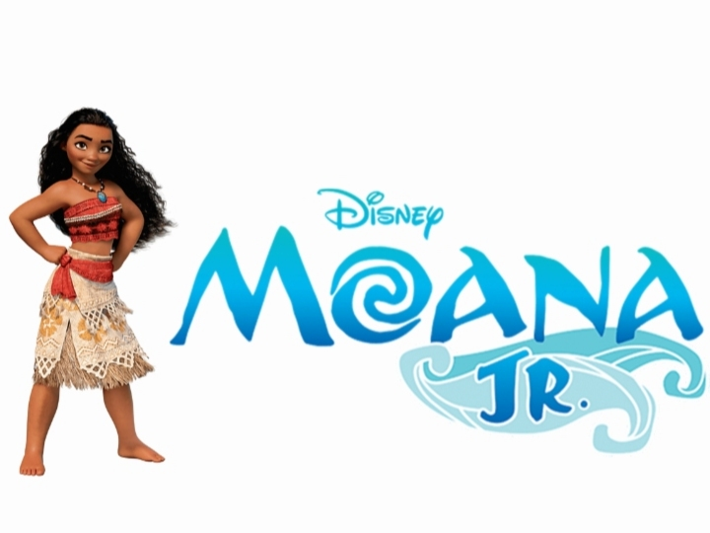

Music and Lyrics by

**Lin-Manuel Miranda, Opetaia Foa‘i & Mark Mancina**

Book Adapted by  
**Susan Soon He Stanton**

Music and Orchestrations Adapted and Arranged by

**Ian Weinberger**

Based on the 2016 Disney film *Moana*

**SCENES & MUSICAL NUMBERS**

**Scene 1: Prologue**

In the Beginning… Ancestors

Tulou Tagaloa Ocean

**Scene 2: The Shore/The Village**

Where You Are Chief Tui, Sina, Moana, Hei Hei, Pua,

Gramma Tala, Villagers

**Scene 3: The Village**

**Scene 4: The Shore**

How Far I’ll Go Moana, Pua, Hei Hei, Ocean

We Know the Way Ancestors

Where You Are (Reprise) Gramma Tala

How Far I’ll Go (Reprise) Moana, Chief Ancestors, Ocean

**Scene 5: Maui’s Island**

You’re Welcome Maui, Maui Ensemble

**Scene 6: Canoe at Sea**

Warrior Face (Parts 1 & 2) Maui, Moana

**Scene 7: Lalotai**

Warrior Face (Part 3) Maui, Moana, Gate Monster, Monsters

**Scene 8: Tamatoa’s Lair**

Shiny Tamatoa, Left Claw, Right Claw, Shiny Ensemble

**Scene 9: Canoe at Sea**

Warrior Face (Reprise)/Logo Te Pate Moana, Maui, Ocean

**Scene 10: Canoe at Sea, Near Te Kā**

Song of the Ancestors Gramma Tala, Moana, Ancestors

Know Who You Are Moana, Ocean

Te Fiti Restored Ocean

Tulou Tagaloa (Reprise) Ocean

**Scene 11: Motunui Shore**

We Know the Way (Finale) Moana, Chief Tui, Sina, Pua, Hei Hei,

Ancestors, Villagers, Ocean

Bows Company

**CAST**

(in order of appearance)

Chief Ancestors Mia Valgenti, Ruby O’Brien, Carina Martell

Moana Ryleigh Luethold

Chief Tui Sam Edwards

Sina Briana Garcia

Hei Hei Mackenzie Heim

Pua Kettler Robinson

Gramma Tala Maeve Korth

Maui Liam Pollock

Tamatoa Zoe DeLuc

Te Kā / Te Fiti Sam Stewart

**PRODUCTION TEAM**

Director Krissy Sliwoski

Lighting Designer Abby Ziroli, Charlotte Dery

Stage Manager Dori Donadeo

Asst Stage Managers Jackie Stewart, Grace Buckley

Jr Stage Managers Megan Spears, Molly McCarthy

Sound Director……………………………………….Concept Professionals

Sound Manager………………………………………….……….Chloe Stevens

Asst Sound Managers………………...Carys Devine, Teagan Paradise

Spotlights……….Fernanda Morales, Cindy Garcia, Tess Gennarelli

Boat Technician………………..………….MJ Femenella, Grace Buckley

Water………………………………………….Ella McCarthy, Megan Spears

Stage Crew………...Sarah Gonzalez, Amelia Steger, Sophia Tignini, Lizzet Cordero-Lopez, Sarah Furlong Leonard

Set Construction…………………………………………………Evan Sliwoski

Under Study………………………………………Dave “The Rave” Seeley