**Shark Fossil Analysis**

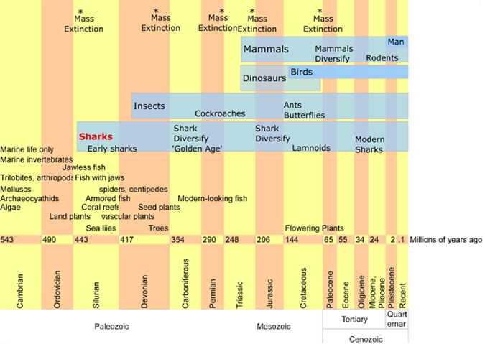

Background (from Sharksavers.org)

Sharks have swum in the oceans for almost 450 years. But longevity is only part of the story. That extra few million years of evolution have enabled many shark species to develop some extraordinary abilities as perfect predators.

Is 450 million years a long time in evolution? Life is thought to have begun on earth about 3.8 billion years ago. Life on earth began as bacteria and did not advance beyond the one-celled format until around 580 million years ago. The first fish appeared around 510 million years ago. These were armored jawless fishes known as ostracoderms. And then came the sharks either 455 or 425 million years ago—there is some disagreement among paleontologists as to when.

Many of us tend to think of dinosaurs as dominating the prehistoric world. But dinosaurs didn’t appear until about 230 million years ago. Mammals first appeared around that same time. The first human-like animal, or hominid, dates to about 4.5 million years ago, but modern humans only date back perhaps 60,000 years. And recorded civilization has lasted only about 5,000 years. That means sharks have existed 100 times longer than hominids and 3 times longer than dinosaurs (or twice as long as dinosaurs if we include birds).

Paleontologists piece together the history of ancient living things, largely through the discovery and analysis of fossils. Fossils are the mineralized or otherwise preserved bodies or impressions of living things.  
  
Problem is, sharks generally don’t fossilize as well as other animals because their skeletons are made of cartilage, a softer and more flexible tissue. Cartilage isn’t as easily fossilized as is bone.

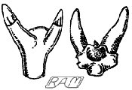

Early shark teeth. All illustrations by R. Aidan Martin

Fortunately, shark teeth do fossilize well, and sharks produce thousands of teeth in a lifetime. Fossilized shark skin scales and, over time, other body parts have also been found. Much of the earliest shark evolution and history is known through fossils of teeth and scales that are unique to sharks. Paleontologists are able to find enough clues in a well-preserved fossil to determine much about a shark, including its species, and clues to suggest size and behavior.

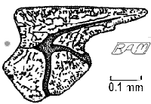

scale of elegestolepis

The oldest fossilized evidence of prehistoric sharks comes from shark-like scales that date to 455 million years ago during the Ordovician Period, in Colorado. Some paleontologists do not agree that these scales are sufficiently shark-like to pronounce them sharks. But there is no disagreement that scales found during the Silurian Period, aged 420 million years, are from sharks. Shark scales from this period have been found in Siberia and Mongolia. The oldest shark teeth are from the Devonian Period, about 400 million years old, found in Europe. Nothing beyond these scales or the teeth is known about these early sharks.

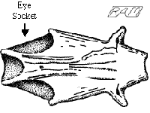

Braincase, 380 million years ago

More complete fossil shark remains date to 380 million years old, including a fossilized shark braincase, possibly a xenacanth, found in Australia. Other remains of this or similar species have been found in Antartica and Saudi Arabia. Xenocanth was a fresh water shark.

**Mass Extinctions and Adaptive Radiations**

Throughout history there is evidence of catastrophic events that dramatically changed the environment and resulted in the mass extinction of a significant percentage of species. In the worse such event, 251 million years ago, as many as 95% of species were killed, perhaps due to either a comet impact or volcanic activity. Five major mass extinction events have occurred during the past 439 million years.   
  
For surviving species, these mass extinctions can provide an opportunity to flourish if previous predators disappeared or new, inviting habitats opened up. These, in turn, have sometimes given rise to ‘adaptive radiations’, or a dramatic increase in new diverse species. Sharks have survived all five of these mass extinctions, a testament to their versatile design. They have also benefited from a few adaptive radiations, giving rise to many interesting sharks. The first major shark radiation occurred 360 to 286 million years ago.

**A few Prehistoric sharks**

[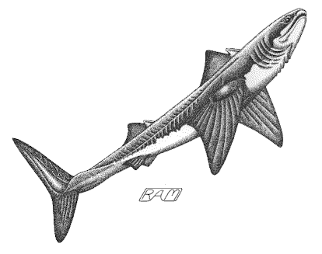](http://www.sharksavers.org/images/stories/RAMimages/cladoselache.gif)

Cladoselache

Even as long as 370 million years ago, sharks would have been recognizable to us as sharks, although many, such as the Cladoselache, had characteristics that would seem unusual to us, now. A four foot shark that was prevalent at that time, Cladoselache still had a mouth in the front of its head, like other ancient sharks, whereas most modern sharks have mouths that are located at the bottom of their head. Unlike most ancient and all modern sharks, Cladoselache lacked tooth-like scales that provide protection and allow muscles to attaché to the skin more strongly. Cladoselache also lacked the claspers that male sharks use to mate with females.

Ctenacanths are sharks that developed around the same time as Cladoselarche and continued on for over a million years. Ctenacanths are best known by their fin spines, which were long and cylindrical, with unique comb-like ridges that gave rise to its name.

[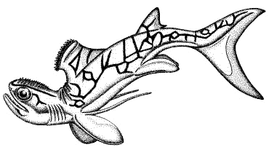](http://www.sharksavers.org/images/stories/RAMimages/stethacanthus.gif)

Stethacanthus

After a mass extinction left the oceans with far fewer fish and many ecological niches left open, one of the more interesting sharks evolved. Stethacanthus was a two-foot long shark that lived in warm, shallow seas. Male Stethacanthus had a flat-topped dorsal fin with enlarged scales that resembled a brush, and similar enlarged scales on top of the head. These strange features must have held some purpose, and suggestions have ranged from being courtship related to offering some sort of protection.

The Stethacanthus was part of a group of sharks called the stethacanthids. This and many other groups of sharks during the Carboniferous Period underwent a large adaptive radiation, giving rise to a ‘Golden Age’ of sharks. This continued until about 250 million years ago when the largest mass extinction killed up to 99% of all ocean species.

**Origin of Modern sharks**

[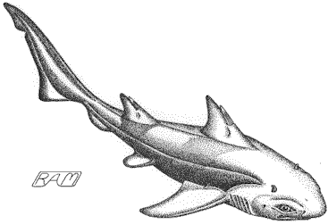](http://www.sharksavers.org/images/stories/RAMimages/hybodus.gif)

Hybodus

Sharks enjoyed another period of adaptive radiation throughout the Jurassic and Cretaceous periods, beginning about 200 million years ago. Modern families of sharks have their roots in this radiation, although no clear lineage has been established. Among the groups of sharks that thrived during this time are the Hybodonts, one of which was an 8 foot shark named Hybodus, that lived in shallow seas 180 million years ago. Hybodonts have been considered a candidate for from which modern sharks are derived, but this is often discounted, now. Another early shark that may have given rise to modern sharks is *Mcmurdodus,* which had an even earlier start of 390 million years ago. Most of the early sharks of this period were near-shore predators. By the mid-Cretaceous, about 100 million years ago, many sharks had evolved into fast-swimming, off-shore predators. It is during this period that modern shark families originated. At the end of the Cretaceous, about 65 million years ago, another global catastrophe destroyed a mass number of species, including the dinosaors. The sharks who survived that extinction include the modern sharks of today.

**Sixgill, Sevengill and Frilled Sharks**

Among the longest existing of modern sharks are the cow sharks (sixgill, sevengill), and frilled sharks (orders Hexanchiformes and Chlamydoselachiformes, respectively). Cow sharks date back 190 million-years ago, during the early Jurassic. The eel-like Frilled Shark shows fossil evidence from 95 million years ago. Most of these animals live in deep waters.

**Filter feeders**

Sometime during the Tertiary Period, 65 to 35 million years ago, several different orders evolved from being predators to filter feeding plankton. The Carpet shark lineage (order Orectolobiformes) gave rise to the modern Whale Shark (Rhincodon typus), two distinct lineages of Mackerel shark (Lamniformes) gave rise to the Basking (Cetorhinus maximus) and Megamouth (Megachasma pelagios) sharks.

**Lamnoids**

[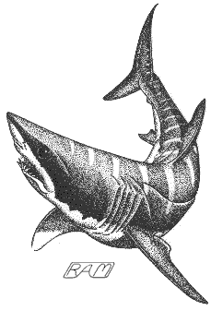](http://www.sharksavers.org/images/stories/RAMimages/cretoxyrhina.gif)

Cretoxyrhina

Lamnoids (order Lamniformes) include some of the best known sharks, such as the ‘Great’ White, thresher sharks, Basking, the Goblin Shark, and Sandtiger. What may be the earliest of the lamnoids, Paleocarcharias stromeri, was found from the upper Jurassic in deposits about 155 million years old. There is limited fossil evidence of the early lamnoids beyond their teeth, but there is enough to suggest that there were several bursts of adaptive radiation producing much diversity. Several complete skeletons have been found of Cretoxyrhina mantelli, a lamnoid about the size of a modern Great White, living about 100 million years ago during the late Cretaceous.

Megalodon was a shark that was perhaps 50 feeet long, much larger than the Great White, with teeth measuring 7 inches compared to up to three inches for the White.Megalodon most likely evolved from Cretolamna appendiculata, which existed between 100 and 60 million years ago. The fossil record of Megalodon lasts only between 16 million years ago and about 1.6 million years ago, when they suddenly died out.

[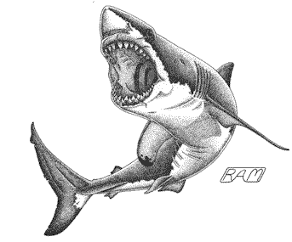](http://www.sharksavers.org/images/stories/RAMimages/megalodon.gif)

Megalodon

But there were significant similarities to tempt comparison. Both species share the famous searrated teeth that are able to bite, taste-test, and tear apart large animals. While some paleontologists believe the Megalodon may share a distant relative, it is now accepted that the Great White is not a direct descendent and, in fact, coexisted for about 10 million years. It is suggested that these two predators kept out of each other’s way by feeding on different prey - megalodon on whales, the white shark on seals - and living in different areas - Megalodon in warm water, the White Shark in cooler water.  
  
Where did the Great White Shark, itself, come from? There are differing schools of thought on this question and much revolves around the study of teeth--smooth vs. serrated, and which path the Great White took. If Great Whites evolved from the same line as the huge Megalodon, then we might look to a potential common ancestor, the Cretolamna appendiculata, found in late Cretaceous to the mid-Paleocene about 100 to 60 million years ago. Opposing that theory is one that says Great White teeth are more similar to the mako, and trace ancestry to the Isurus hastalis, whose teeth were found In Oligocene deposits from about 30 million years ago. Whatever the origin, the modern White Shark, Carcharodon carcharias, first appeared about 11 million years ago.

**Hammerheads**

Hammerheads (family Sphyrnidae of the order Carcharhiniformes, or Ground Sharks) is perhaps the most unusual of modern sharks. Hammerheads are also among the most recent. Hammerhead teeth first appear in mid-to-late Eocene deposits, from about 50 to 35 million years ago.

**Sharks evolutionary challenge: Perfection vs. Man**

We began this article by describing sharks as perfect predators. Sharks have certainly developed remarkable capabilities to find and catch its prey. But these capabilities, as well as the ability to reproduce and flourish, work best in a stable environment with no highly effective natural predators. Enter man. Man’s recent rapacious slaughter of sharks does not mesh well with shark reproductive capacity. Most sharks take years to reach sexual maturity and raise few pups in a lifetime. This makes them ill equipped to respond to man. Thus, the 450 million year legacy of sharks may well be meeting its greatest challenge.

Procedure

Find each fossil and record the following:

1. Draw the fossil(s)
2. What you think it is
3. What you think its function was (explain, talk about how its form relates to its function)
4. Kind of shark (skate, or ray) it may be from
5. Size of the shark it may be from (can be a range)
6. Possible age

Fossil Number 1

Fossil Number 2

Fossil Number 3

Fossil Number 4

Fossil Number 5

Fossil Number 6

Results questions:

1. What kinds of things do you think ancient shark experts could learn from these fossils? How?
2. What are the potential problems of studying ancient sharks? Again, Explain.
3. In what ways have you seen or read about today are sharks well adapted to their environment?